Labour History Project Working People: A History of Labour in BC
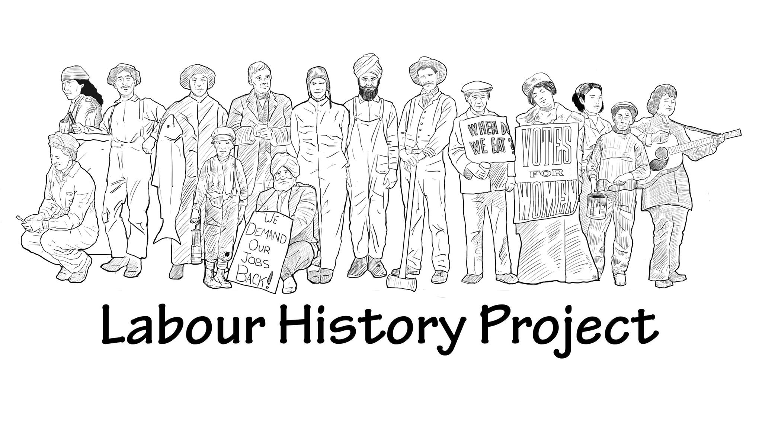

Vancouver Island War

Film Summary: Highlights the 1912-1914 Big Strike in Vancouver Island coal mines where miners and mine owners clashed over worker safety. The film highlights the methods used by both sides to resolve the conflict including the use of police, militia and violent protests.

The Essential Question: How can the study of events of the past, like the “Vancouver Island War”, allow us to better understand labour, human rights and economic issues today?

What historical factors
Curriculum Application
Social Studies 9
Social Studies 10

Summary of the Lesson Activities

- Focus questions for the vignette provide a short lesson option. (15 minutes)
- Video overview activity to be completed individually or in small groups.
- Directed reading exercise with guided questions to compare the experiences of the miners in the video with contemporary miners in Mexico.
- Small group activity to compare the video with a reading article and opportunities for large group discussion.
- Opportunities to relate the video and article to current worker safety issues.

Learning Standards
- Use Social Studies inquiry processes and skills to ask questions; gather, interpret, and analyze ideas; and communicate findings and decisions
- Compare and contrast continuities and changes for different groups at the same time period (continuity and change)
- Explain and infer different perspectives on past or present people, places, issues, or events by considering prevailing norms, values, worldviews, and beliefs (perspective)
- Make reasoned ethical judgments about actions in the past and present, and determine appropriate ways to remember and respond
(ethical judgment)

Materials and Resources Provided

“Vancouver Island War” Episode 2- Working People – a History of Labour in British Columbia
Activity 1 Article Analysis Sheet
Activity 2 Video Information Organizer
Appendix 1- Tyee Article “Embattled Striking Miners”
Appendix 2- Lesson Strategy

Additional Suggested Materials
- Working People: A History of Labour in British Columbia Lessons
- Miners vs. Dunsmuirs
- Childrn at Work
- Ginger Goodwin
- The Labour Movement in British Columbia 1840 to 1914
- These were the reasons Video Ch. 2
- On the Line: A History of the British Columbia Labour Movement Ch 4 pages 50-56
- Vancouver Island Coal Strike - British Columbia - An Untold History (knowledge.ca)
- British Columbia: An Untold History-Labour and Persistence

bctf/ufcw1518
Vignette Questions
- In the three decades preceding the Vancouver Island War, how many miners had been killed in mining accidents?
- What were the main causes of these accidents?
- How did the Miners of the Extension respond to the company’s refusal to shut the mine for safety reasons?
- What actions did Premier McBride take to deal with the Miners strikes?
- How did the mine owners respond to the strike?
Lesson Activities
- A short lesson option is to watch the video and use the Vignette questions above and or the Video Information organizer provided in Activity one as an extension to the coverage of the topic “Fighting for Labour Rights” in the Grade 9 Social Studies text, Horizons: Canada’s Emerging Identify.
- Follow the lesson strategy provide by the author (Appendix 2) to incorporate the video viewing and the reading and discussion of an article that can be used to compare and contrast the recent experiences of miners in Mexico and the miners of Vancouver Island in the past.
- Additional vignettes and lessons that deal with coal mining in this time period can be found at the BC Labour Heritage Centre website. In addition, the video “These were the reasons..”, chapter 2, is available at the Labour Heritage Centre’s websites. There are extra resources on the Great Coal Strike of 1912-1914 also available on the BC Labour Heritage Centre’s Website.
- The vignette "Coal Miners Lament" from the Edge of the World Series; BC’s Early Years can also be used to develop an extended unit on this topic.
Credit: Teaching Activities and Lesson Plan developed by John Decaire

